BPL Global becomes the first corporate sponsor of Insulate Ukraine

  - BPL Global is proud to announce its support of Insulate Ukraine. The project seeks to temporarily restore bullet and bomb-damaged buildings in towns and villages across war-torn Ukraine with specially designed plastic windows, allowing for uninhabitable homes to become liveable again.
BPL Global’s partnership with Insulate Ukraine has so far improved the lives of over 150 people in the past month, having insulated more than 100 homes – or over 500 windows – in the city of Izyum and two settlements in eastern Ukraine. This included making bombed-out homes in Karovii lar habitable and the restoration of a local administration building in Drobyshevo.
Insulate Ukraine’s windows were designed by PhD student Harry Blakiston Houston, from the University of Cambridge, who has since paused his studies to focus on the project.
In recent weeks, Insulate Ukraine has received national media attention including segments on the BBC and ITV news channels.
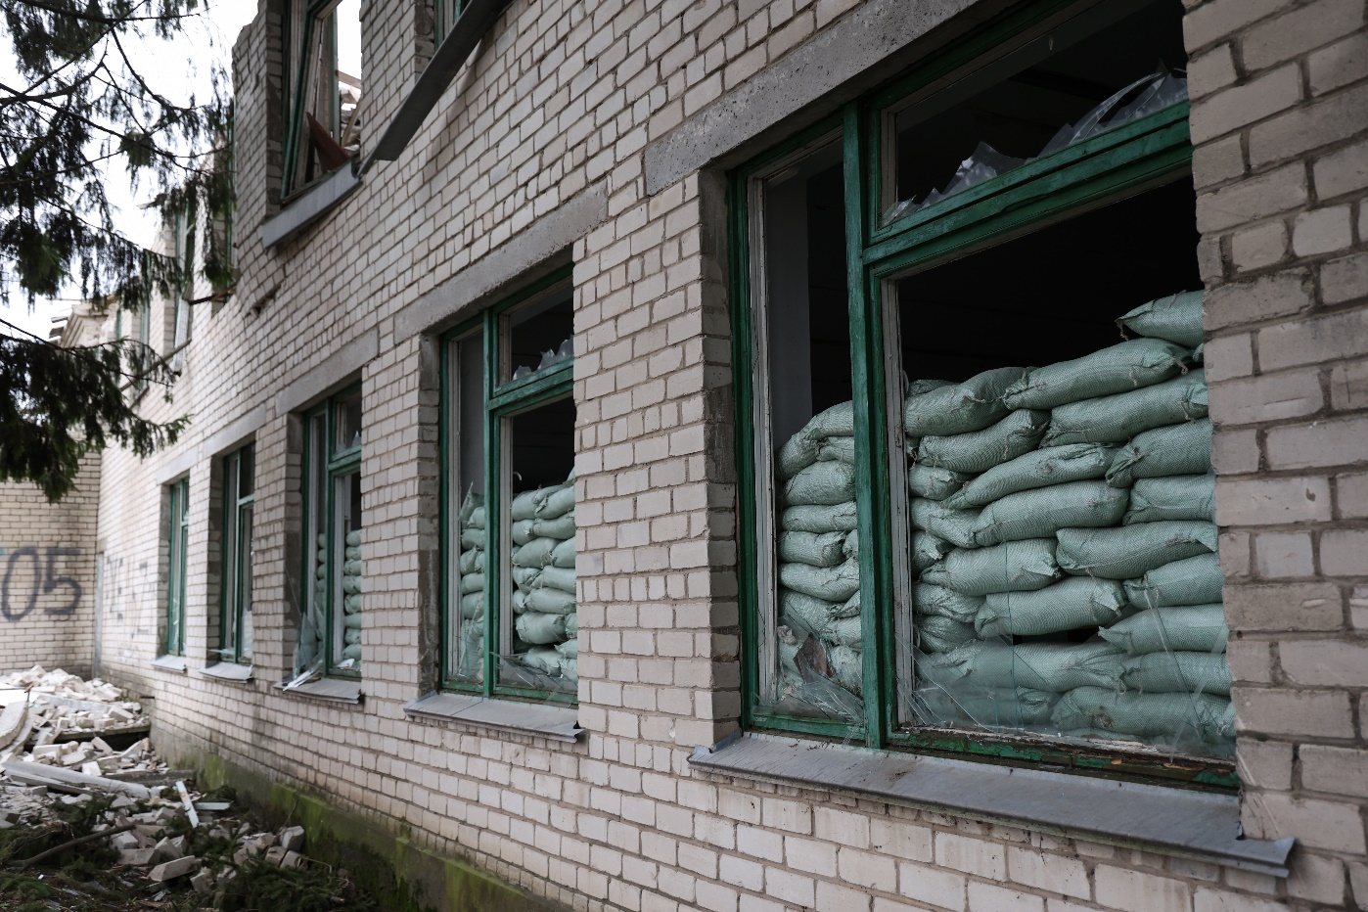
(Credit: Insulate Ukraine)
Harry stresses the importance of teaching local people to construct and install the windows. He adds: “We’re giving Ukrainians the power to solve this problem for themselves. All we need to do is show them how to make the windows and help them obtain the materials.” He adds, “The corporate support from BPL Global has been invaluable, allowing us to provide the necessary materials and man-power to make a real difference to the lives of hundreds who are suffering through the harsh realities of war.”
“We are proud to support the Insulate Ukraine project and promote the incredible work being done by Harry and the team.” says Matthew Graham, Compliance Director and Chairman of BPL Global’s Charity Committee. “It is great to see that as the project’s first corporate sponsor, in only a matter of weeks, we have been able to make real difference to those impacted by the conflict. We look forward to continuing to support Insulate Ukraine over the months ahead, as it looks to expand its work into further towns and cities in eastern Ukraine.”
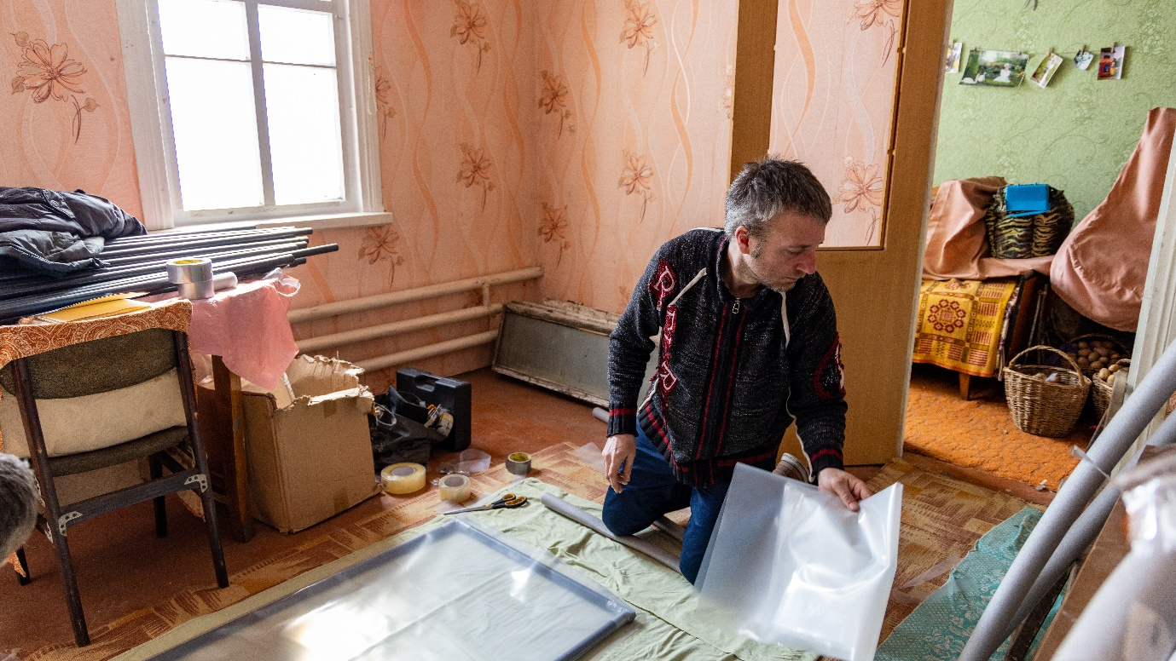
(Credit: Insulate Ukraine)
Insulate Ukraine’s window design, which can be built in just 15 minutes, uses four layers of insulation comprising polyethylene, PVC piping, pipe insulation and duct tape. The cost is approximately £12 per square metre of window.
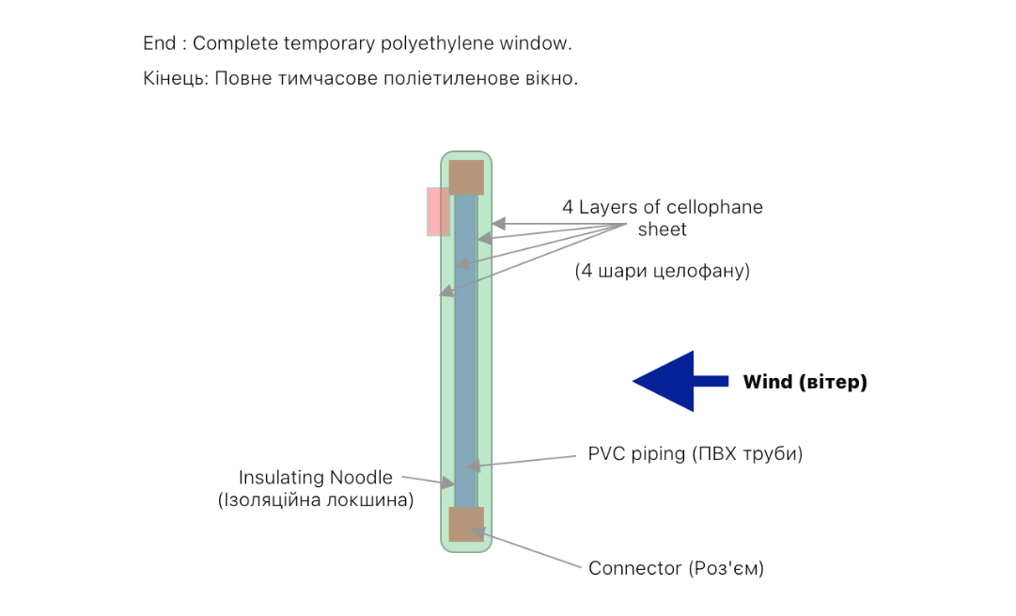
(Licenced under CERN Open Hardware Licence Version 2 - Permissive)
To find out more about Insulate Ukraine and how you can support the project, visit the website; or follow them on Instagram.
Further information on the organisations BPL Global has supported can be found here.

